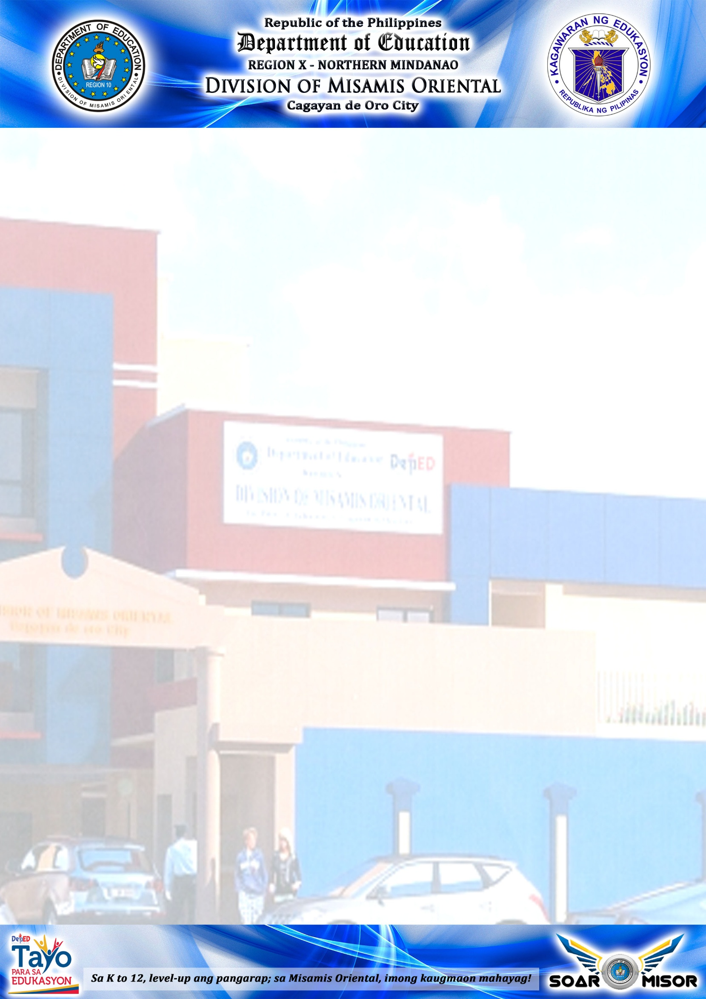

**2017**

**SEARCH FOR OUTSTANDING**

**EDUCATION PROGRAM SUPERVISOR**

**(Name)**

**(Position/Designation)**

**(Division/Office)**



**2017**

**SEARCH FOR OUTSTANDING**

**PUBLIC SCHOOLS DISTRICT SUPERVISOR**

**(Name)**

**(Position/Designation)**

**(District)**



**2017**

**SEARCH FOR OUTSTANDING**

**ELEMENTARY SCHOOL HEAD**

**(Name)**

**(Position/Designation)**

**(School)**

**(District)**



**2017**

**SEARCH FOR OUTSTANDING**

**SECONDARY SCHOOL HEAD**

**(Name)**

**(Position/Designation)**

**(School)**

**(District)**



**2017**

**SEARCH FOR OUTSTANDING**

**ELEMENTARY SCHOOL TEACHER**

**(Name)**

**(Position/Designation)**

**(School)**

**(District)**



**2017**

**SEARCH FOR OUTSTANDING**

**SECONDARY SCHOOL TEACHER**

**(Name)**

**(Position/Designation)**

**(School)**

**(District)**



**2017**

**SEARCH FOR OUTSTANDING**

**KINDERGARTEN TEACHER**

**(Name)**

**(Position/Designation)**

**(School)**

**(District)**



**2017**

**SEARCH FOR OUTSTANDING**

**SPED TEACHER**

**(Name)**

**(Position/Designation)**

**(School)**

**(District)**



**2017**

**SEARCH FOR OUTSTANDING**

**DISTRICT ALS COORDINATOR**

**(Name)**

**(Position/Designation)**

**(School)**

**(District)**



**2017**

**SEARCH FOR OUTSTANDING**

**MOBILE TEACHER**

**(Name)**

**(Position/Designation)**

**(School)**

**(District)**



**2017**

**SEARCH FOR OUTSTANDING**

**NON-TEACHING PERSONNEL**

**(Name)**

**(Position/Designation)**

**(School)**

**(District)**